## PATIENT HOME SCREEN

The Patient Home Screen contains basic patient information, summary views, and detailed administrative and clinical data. The patient’s name, age/gender, DOB, MRN, and allergies (if available) are listed at the top of the page. Clicking the arrow beside the patient’s name collapses/expands the header information.



Additional information (including the source, if available) can be displayed by hovering your cursor over any of the fields.

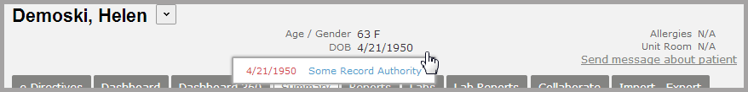

**Sending Messages**

Selecting **Send message about patient** allows a clinician to send a message within patient context to another provider. See the “Direct Messaging” section for more information about sending messages.

